
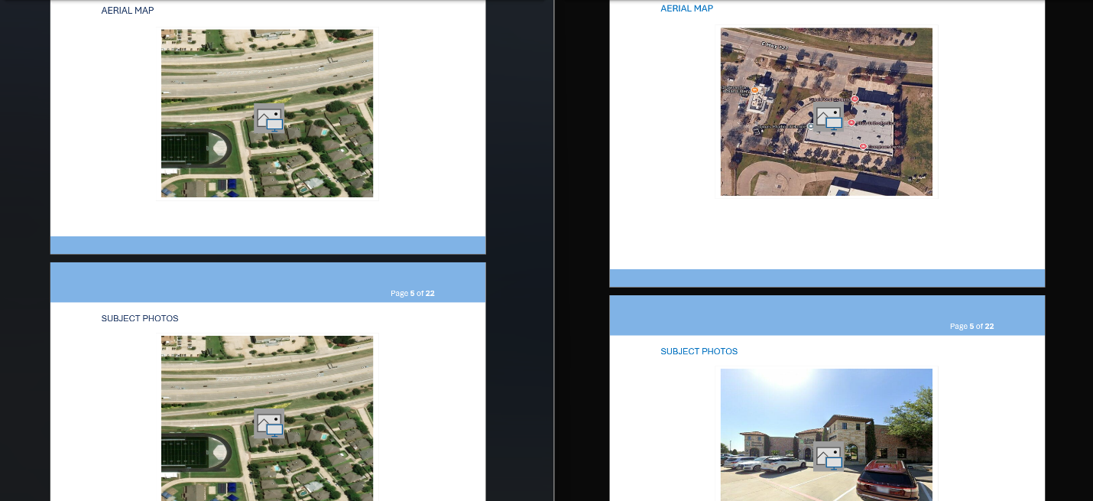
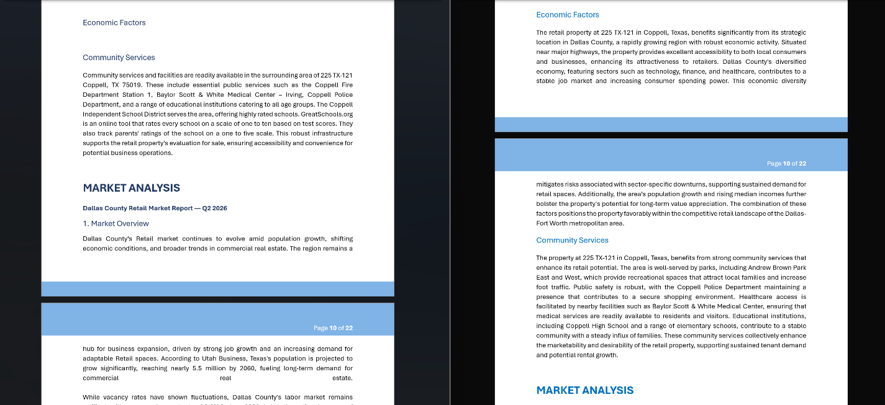

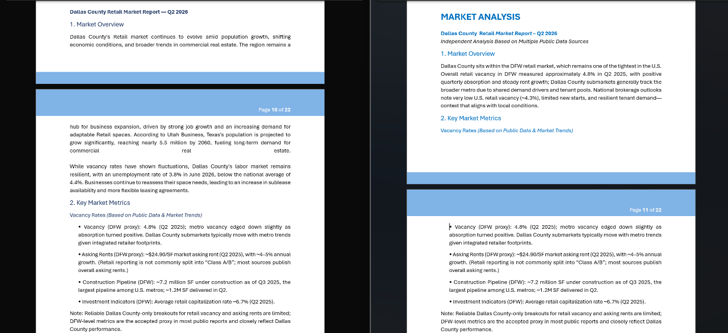
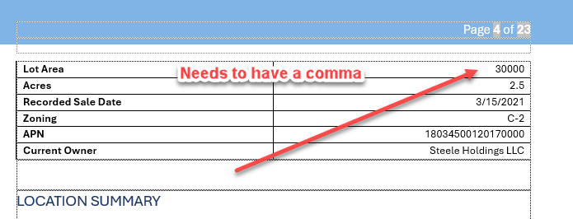
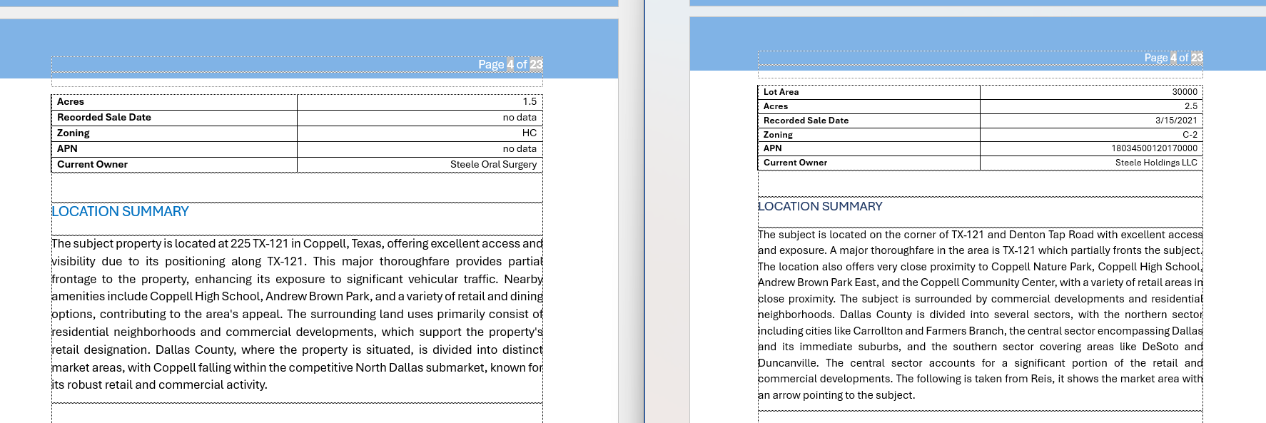
The image above shows different data between the two reports. The one on the left is from the previous template, and the one on the right is the one you just sent us.
We need these to be more consistent. The newer version is not consistent in the same fields that were included before, like lot area, recorded sale date, APN, and some of the property details. The location summary is also a lot shorter and does not have the same level of detail as the older template.
Is there a way to make the AI-generated reports follow the same format as the previous template, with the same fields in the same order and a more detailed location summary when the information is available?
Same issue with the overview in the image below for the regional analysis. They need to be more consistent, not different information every time. Again the image on the right is a previous report generated and the image on the left is the one you just provided to us.
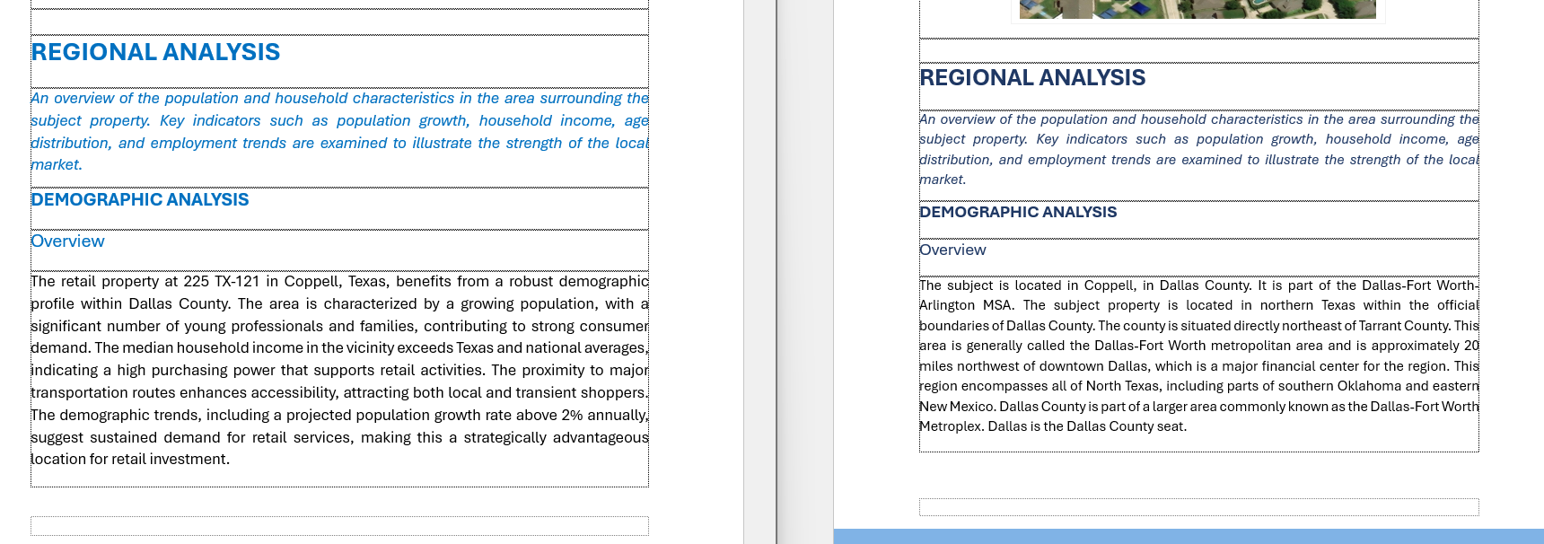
Again there are consistency issues:
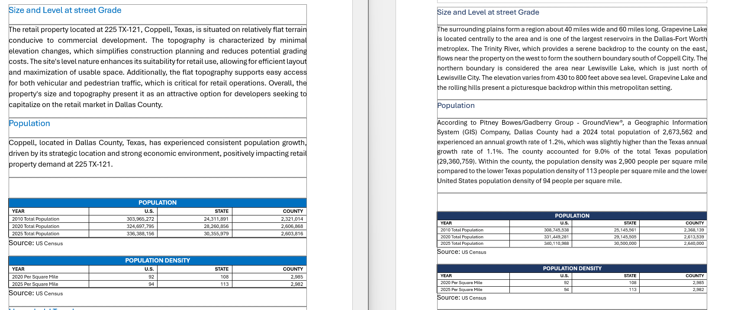
Is the 2010-2019 information for employment the most recent that our API allows for? There should be more recent information. See below
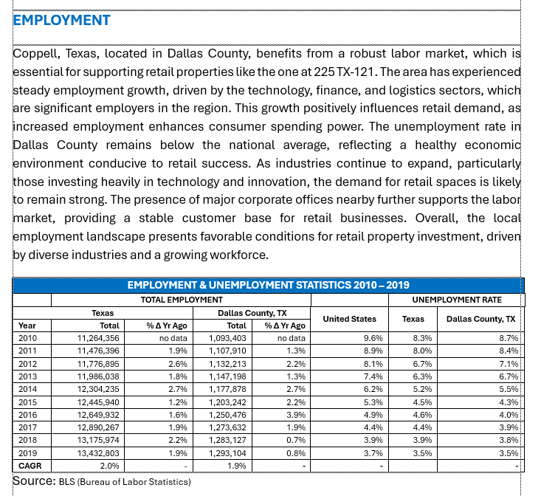
The lease rates and construction activity paragraphs are the exact same between these reports I just want to make sure that these are updated by the AI. Again the image on the left is the most recent report you provided and the one on the right is an old report generated.
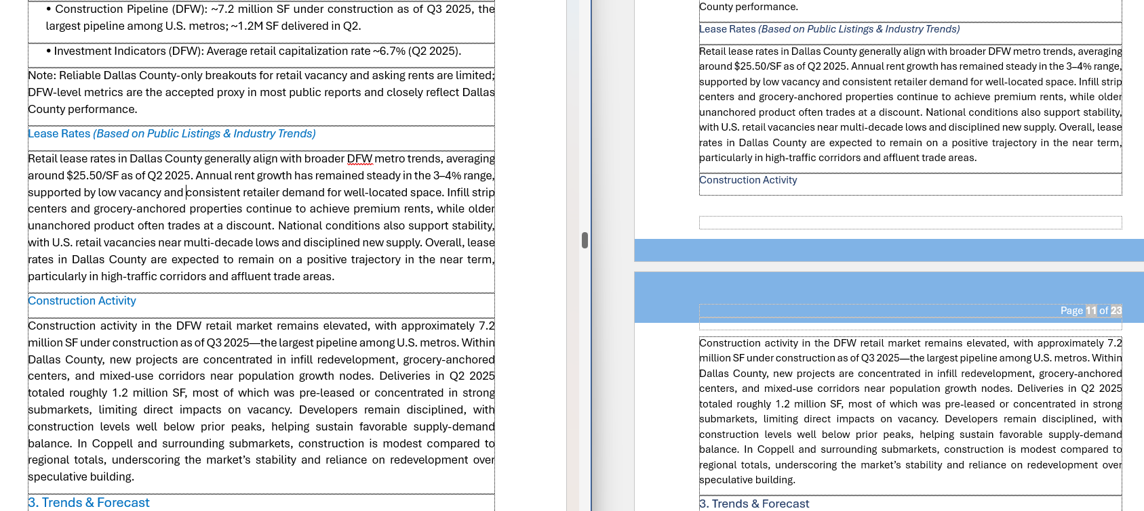
The data sources are from 2023 do we need to find you better data sources that are more up to date or are these the most recent reports that the AI has access to. If we need to find more updated sources we can:
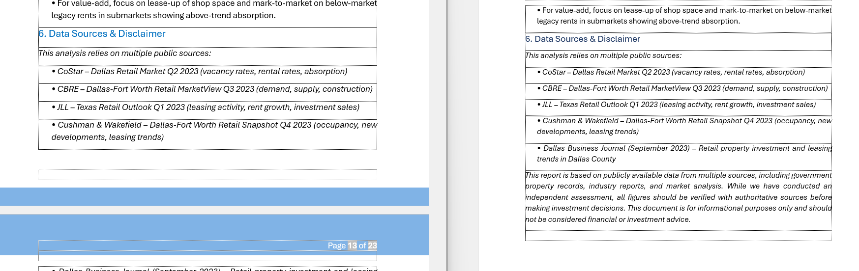
Page 14 has a blank page on it.
